**香港证监会：部分ICO代币在港需受证券法规监管**

编辑：徐雪 2017.9.5

“香港证监会表示，部分ICO项目发行的代币可能属于证券…”

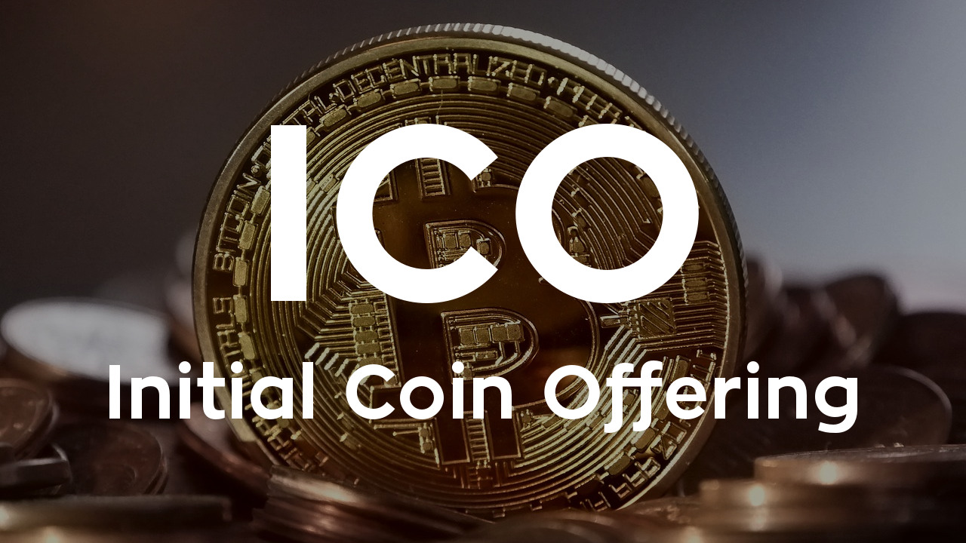

继9月4日七部委联合叫停ICO后（《中国人民银行 中央网信办 工业和信息化部 工商总局 银监会 证监会 保监会关于防范代币发行融资风险的公告》），9月5日，香港证监会也发布了《有关首次代币发行的声明》。声明指出，部分进行ICO的项目代币可能属于《证券及期货条例》所界定的“证券”，如果在港进行ICO类似活动，可能需要受到香港证券法例的规管。而从事“受规管活动”的人士或机构，不论是否位处香港，只要其业务活动对象是香港公众，均须获证监会发牌或向证监会注册才可继续进行。

标签：ICO；香港证监会

总浏览数：***

*【声明：文章为作者独立观点，不代表UNITIMES官网立场。欢迎转载，转载请务必注明来源。如有不当之处请多指教】*

**Hong Kong SFC: ICO Tokens “May be Securities” & Subject to Laws**

Editor: Xue Xu 5 Sept, 2017

“HongKong SFC suggests that some tokens issued by ICO projects may belong to securities…”



On September 5, 2017, Hong Kong Securities and Futures Commission (SFC) released the *Statement on Initial Coin Offerings*, announcing that certain ICO tokens might be securities as defined in the Securities and Futures Ordinance (SFO), and subjected to the securities laws of Hong Kong. And parties engaging in a “regulated activity” are required to be licensed by or registered with the SFC irrespective of whether the parties involved are located in Hong Kong, so long as such business activities target the Hong Kong public.

Just the day before, seven government authorities in Chinese mainland jointly issued a Statement on the ban of ICO activities, calling for the immediate halt of all ICO tokens issuance within the country.

标签：ICO； SFC

总浏览数：***

*【Declaration: Please indicate the source if repost the article in UNITIMES. Opinions expressed by Contributors belong to themselves.】*